English April 13th:

Starter:

* You have to be for or against
* You should have consider both sides in an argument
* You have to consider response to your points
* You have to amend your argument to fit the audience
* You have to be persuasive

Task 1:

* Sequencing the argument in an organized fashion will make a powerful debate
* Consider all arguments to have the biggest impact on the reader
* However still choose 1 side
* Using conjunctions will help organize then argument
* P: urpose

A: udience

L: anguage

L: ayout

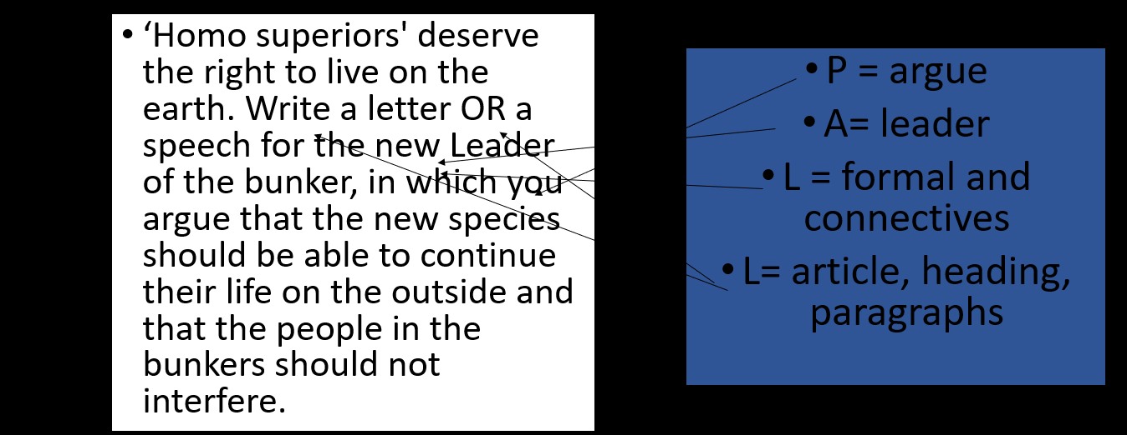

* Think carefully
* Use PALL
* Use connectives

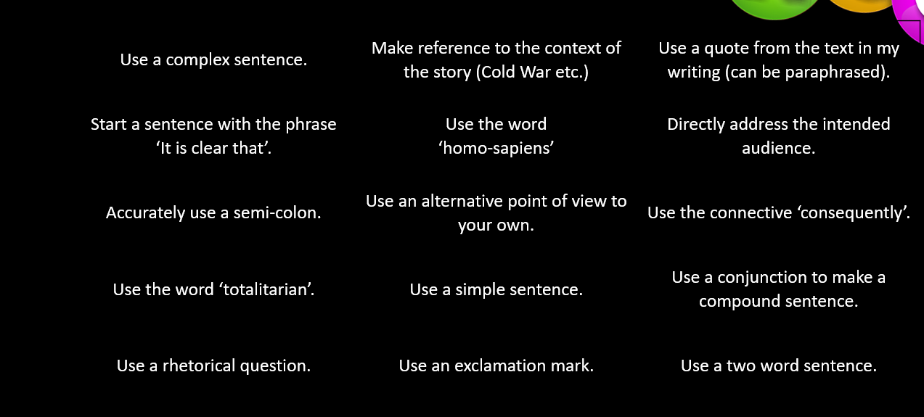

Task 2:

Dear General MacAllister,

How? Why? How dare you! Leaving these people to die! They are us, they are better than us, they are the future of humanity. It is almost certain that we will not survive, there is no way we can rebuild a society in time and Dwight is too rebellious to do so.

Haven’t you always thought about how the others feel outside this wretched bunker? Its true, during an apocalypse it should be every person for themselves however when the other person has more chance of surviving than you. Every person plays a role in saving the world in this time, only this time, the aftermath during the cold war.

Even Bill, Erica, Dwight and Olivia left because of you. You said Dwight was your hope, well good luck with that! You just drove your last hope out of your bunker.

The way I see it, you are fighting for a lost cause and you are blinded by your own arrogance and you can’t see that you are failing, your already dead. People like Catherine are very imperative, and you should try to help them survive and keep humanity going.

Let me give you some advice, expand your circle of trusted people so you will be able to know who likes and who doesn’t then you can improve based on what they don’t like about you.